Graphic Organizer
Biography 2
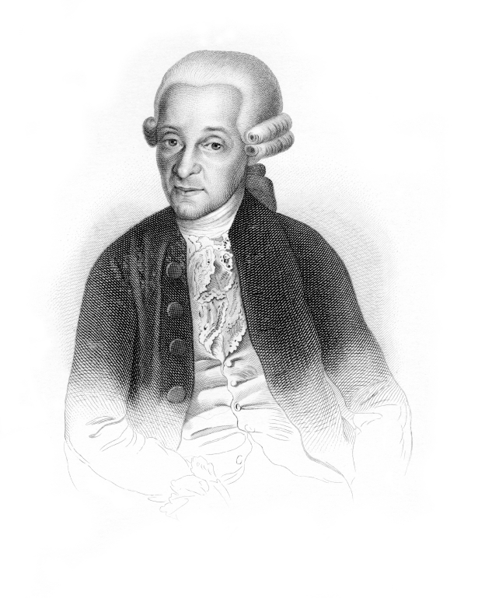
Someone: | Erase and put the name of the person here
Famous for |  | But
Erase and type the person’s main accomplishments |  | Erase and type any struggles or challenges the person faced
Then |  | So
Erase and type how the person overcame it all |  | Erase and type what the person went on to do

Summary
Erase and type a summary here

